 # QUESTION 1

Your Friend has developed the Product and he wants to establish the product startup and he is searching for a perfect location where getting the investment has a high chance. But due to its financial restriction, he can choose only between three locations - Bangalore, Mumbai, and NCR. As a friend, you want to help your friend deciding the location. NCR include Gurgaon, Noida and New Delhi. Find the location where the most number of funding is done. That means, find the location where startups has received funding maximum number of times. Plot the bar graph between location and number of funding. Take city name "Delhi" as "New Delhi".

Check the case-sensitiveness of cities also. That means, at some place instead of "Bangalore", "bangalore" is given. Take city name as "Bangalore". For few startups multiple locations are given, one Indian and one Foreign. Consider the startup if any one of the city lies in given locations.

#QUESTION EXPLANATION

As in this question we have to find the top five cities according to investments received, so after writing the code the output came is as follows

Bangalore 627

Mumbai 446

New Delhi 381

Gurgaon 240

Noida 78

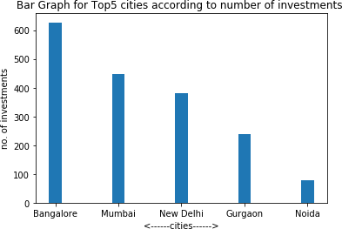

As this graph shows Bangalore is the best location to start the startup followed by Mumbai New Delhi , Gurgaon and Noida , among these cities Noida is least preferred.

#QUESTION 2

Even after trying for so many times, your friend’s startup could not find the investment. So you decided to take this matter in your hand and try to find the list of investors who probably can invest in your friend’s startup. Your list will increase the chance of your friend startup getting some initial investment by contacting these investors. Find the top 5 investors who have invested maximum number of times (consider repeat investments in one company also). In a startup, multiple investors might have invested. So consider each investor for that startup. Ignore undisclosed investors.

#QUESTION EXPLANATION

As in this question we have to find the top five investors according to investments made by them, so after writing the code the output came is as follows

Sequoia Capital 64

Accel Partners 53

Kalaari Capital 44

SAIF Partners 41 Indian Angel Network 40

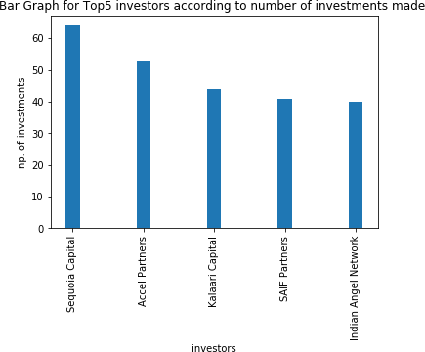

These 5 investors have made investments maximum number of times and can be considered for getting investments ‘Sequoia Capital’ is the

best amongst them and has invested 64 times but the thing is that these investors may have invested in same company multiple times also, so finding the investors who invest in diff. companies would be a better option.



# QUESTION 3

After re-analysing the dataset you found out that some investors have invested in the same startup at different number of funding rounds. So before finalising the previous list, you want to improvise it by finding the top 5 investors who have invested in different number of startups. This list will be more helpful than your previous list in finding the investment for your friend startup. Find the top 5 investors who have invested maximum number of times in different companies.

That means, if one investor has invested multiple times in one startup, count one for that company. There are many errors in startup names. Ignore correcting all, just handle the important ones - Ola, Flipkart, Oyo and Paytm.

#QUESTION EXPLANATION

As in this question we have to find the top five investors according to investments made by them in different startups only, so after writing the code the output came is as follows

Sequoia Capital 49

Accel Partners 47

Kalaari Capital 41 Indian Angel Network 40 Blume Ventures 36

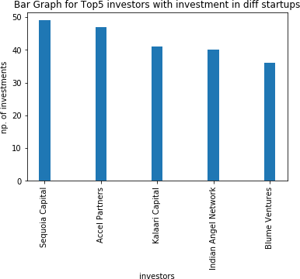

This result would be more beneficial as it contains those top 5 startups with investments in different companies only here also Sequoia Capital wins the race so I guess approaching them would be more fruitful.

 # QUESTION 4

Even after putting so much effort in finding the probable investors, it didn't turn out to be helpful for your friend. So you went to your investor friend to understand the situation better and your investor friend explained to you about the different Investment Types and their features. This new information will be helpful in finding the right investor. Since your friend startup is at an early stage startup, the best-suited investment type would be - Seed Funding and Crowdfunding. Find the top 5 investors who have invested in a different number of startups and their investment type is Crowdfunding or Seed Funding.

Correct spelling of investment types are - "Private Equity", "Seed Funding", "Debt Funding", and "Crowd Funding". Keep an eye for any spelling mistake. You can find this by printing unique values from this column. There are many errors in startup names. Ignore correcting all, just handle the important ones - Ola, Flipkart, Oyo and Paytm.

#QUESTION EXPLANATION

As in this question we have to find the top five investors according to investments made by them in different startups only and their investment type is **Seed Funding and Crowdfunding**, so after writing the code the output came is as follows:

Indian Angel Network 33 Rajan Anandan 23

LetsVenture 16

Anupam Mittal 16

Kunal Shah 14

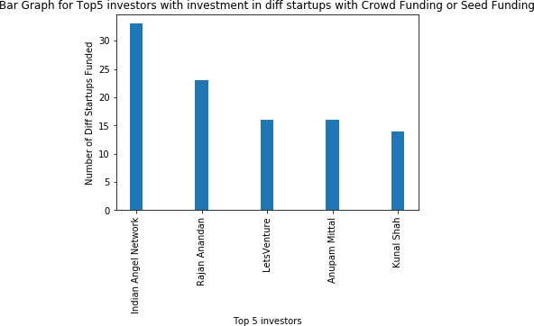

As the startup is an early stage startup so seed funding and crowd funding would be the best type of funding so according to this filter the results are as follows – ‘Indian Angel Network’ Has made the funding maximum number of times in our required type of investment only so approaching them would be a boon but the other four can also be considered.

# QUESTION 5

Due to your immense help, your friend startup successfully got seed funding and it is on the operational mode. Now your friend wants to expand his startup and he is looking for new investors for his startup. Now you again come as a saviour to help your friend and want to create a list of probable new new investors. Before moving forward you remember your investor friend advice that finding the investors by analysing the investment type. Since your friend startup is not in early phase it is in growth stage so the best-suited investment type is Private Equity. Find the top 5 investors who have invested in a different number of startups and their investment type is Private Equity. Correct spelling of investment types are - "Private Equity", "Seed Funding", "Debt Funding", and "Crowd Funding". Keep an eye for any spelling mistake. You can find this by printing unique values from this column.There are many errors in startup names. Ignore correcting all, just handle the important ones - Ola, Flipkart, Oyo and Paytm.

#QUESTION EXPLANATION

As in this question we have to find the top five investors according to investments made by them in different startups only and their investment type is private Equity, so after writing the code the output came is as follows

Sequoia Capital 45

Accel Partners 42

Kalaari Capital 35

Blume Ventures 27

SAIF Partners 24

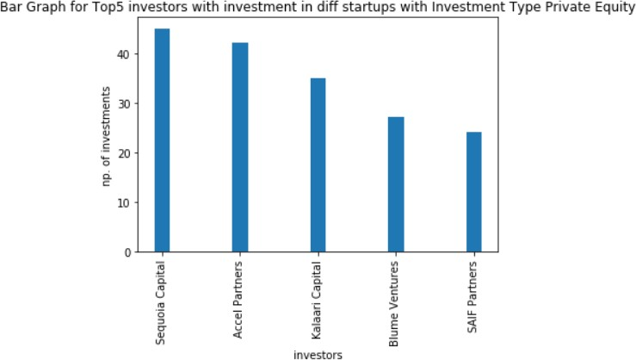

It is very great that the startup now has become a middle aged one. So now as more funding is required and private equity type of investment would be preferable so these five investors have toped the list and also they have invested in diff. companies only and one more time Sequoia Capital has toped the list , you can approach any of these five but as always 1st is preferred.